SECTION 1
30 Minutes (20 Questions)
1. The 180 students in a group are to be seated in rows so that there is an equal number of students in each row. Each of the following could be the number of rows EXCEPT
(A) 4
(B) 20
(C) 30
(D) 40
(E) 90
2. A parking garage rents parking spaces for $10 per week or $30 per month. How much does a person save in a year by renting by the month rather than by the week?
(A) $140
(B) $160
(C) $220
(D) $240
(E) $260
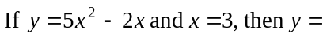3.
(A) 24
(B) 27
(C) 39
(D) 51
(E) 219

4. Of the following, which is the best approximation to 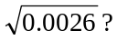
(A) 0.05
(B) 0.06
(C) 0.16
(D) 0.5
(E) 0.6
5. At a certain diner, a hamburger and coleslaw cost $3.59, and a hamburger and french fries cost $4.40. If french fries cost twice as much as coleslaw, how much do french fries cost?
(A) $0.30
(B) $0.45
(C) $0.60
(D) $0.75
(E) $0.90
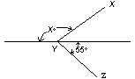
6. If ∠XYZ in the figure above is a right angle, what is the value of x?
(A) 155
(B) 145
(C) 135
(D) 125
(E) 110
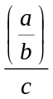
7. In the expression above, a, b, and c are different numbers and each is one of the numbers 2, 3, or 5. What is the least possible value of the expression?
(A) 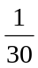
(B) 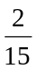
(C)
(D) 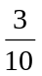
(E)
8. A certain culture of bacteria quadruples every hour. If a container with these bacteria was half full at 10:00 a.m., at what time was it one-eighth full?
(A) 9:00 a.m.
(B) 7:00 a.m.
(C) 6:00 a.m.
(D) 4:00 a.m.
(E) 2:00 a.m.
9. Al, Lew, and Karen pooled their funds to buy a gift for a friend. Al contributed $2 less thanof the cost of the gift and Lew contributed $2 more thanof the cost. If Karen contributed the remaining $15, what was the cost of the gift?
(A) $24
(B) $33
(C) $36
(D) $43
(E) $45
10. What is the total number of integers between 100 and 200 that are divisible by 3?
(A) 33
(B) 32
(C) 31
(D) 30
(E) 29
11. Which of the following inequalities is equivalent to 10 – 2x > 18?
(A) x > -14
(B) x > -4
(C) x > 4
(D) x < 4
(E) x < -4
12. In 1979 approximately of the 37.3 million airline passengers traveling to or from the United States used Kennedy Airport. If the number of such passengers that used Miami Airport was the number that used Kennedy Airport and 4 times the number that used Logan Airport, approximately how many millions of these passengers used Logan Airport that year?
(A) 18.6
(B) 9.3
(C) 6.2
(D) 3.1
(E) 1.6
13. A certain basketball team that has played of its games has a record of 17 wins and 3 losses. What is the greatest number of the remaining games that the team can lose and still win at least of all of its games?
(A) 7
(B) 6
(C) 5
(D) 4
(E) 3
14. Dan and Karen, who live 10 miles apart meet at a cafe that is directly north of Dan’s house and directly east of Karen’s house. If the cafe is 2 miles closer to Dan’s house than to Karen’s house, how many miles is the cafe from Karen’s house?
(A) 6
(B) 7
(C) 8
(D) 9
(E) 10
15. If n is an integer and 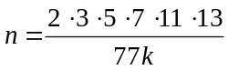then which of the following could be the value of k?
(A) 22
(B) 26
(C) 35
(D) 54
(E) 60
16. There were 36.000 hardback copies of a certain novel sold before the paperback version was issued. From the time the first paperback copy was sold until the last copy of the novel was sold. 9 times as many paperback copies as hardback copies were sold. If a total of 441.000 copies of the novel were sold in all, how many paperback copies were sold?
(A) 45.000
(B) 360.000
(C) 364.500
(D) 392.000
(E) 396.900
17. In the formula 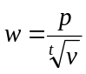 , integers p and t are positive constants. If w =2 when v = 1 and if 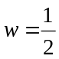 when v = 64, then t =
(A) 1
(B) 2
(C) 3
(D) 4
(E) 16
18. Last year Mrs. Long received $160 in dividends on her shares of Company X stock, all of which she had held for the entire year. If she had had 12 more shares of the stock last year, she would have received $15 more in total annual dividends. How many shares of the stock did she have last year?
(A) 128
(B) 140
(C) 172
(D) 175
(E) 200

Month | Average Price  per Dozen
April  May  June | $1.26  $1.20  $1.08
19. The table above shows the average (arithmetic mean) price per dozen of the large grade A eggs sold in a certain store during three successive months. If as many dozen were sold in April as in May, and twice as many were sold in June as in April, what was the average price per dozen of the eggs sold over the three-month period?
(A) $1.08
(B) $1.10
(C) $1.14
(D) $1.16
(E) $1.18
20. If y ≠ 3 and 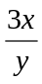 is a prime integer greater than 2, which of the following must be true?
Ⅰ. x = y
Ⅱ. y = 1
Ⅲ. x and y are prime integers.
(A) None
(B) Ⅰ only
(C) Ⅱonly
(D) Ⅲonly
(E) Ⅰand Ⅲ
SECTION 2
30 Minutes (20 Questions)
1. The market value of a certain machine decreased by 30 percent of its purchase price each year. If the machine was purchased in 1982 for its market value of $8,000, what was its market value two years later?
(A) $8,000
(B) $5,600
(C) $3,200
(D) $2,400
(E) $800
2. What percent of 50 is 15?
(A) 30%
(B) 35%
(C) 70%
(D) 300%
(E) 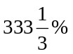
3. In a certain diving competition, 5 judges score each dive on a scale from 1 to 10. The point value of the dive is obtained by dropping the highest score and the lowest score and multiplying the sum of the remaining scores by the degree of difficulty. If a dive with a degree of difficulty of 3.2 received scores of 7.5, 8.0, 9.0, 6.0, and 8.5, what was the point value of the dive?
(A) 68.8
(B) 73.6
(C) 75.2
(D) 76.8
(E) 81.6
4. If 2x = 3y = 10, then 12xy =
(A) 1,200
(B) 200
(C) 120
(D) 40
(E) 20
5. If Jack walked 5 miles in 1 hour and 15 minutes, what was his rate of walking in miles per hour?
(A) 4
(B) 4.5
(C) 6
(D) 6.25
(E) 15
6. Of a certain high school graduating class, 75 percent of the students continued their formal education, and 80 percent of those who continued their formal education went to four-year colleges. If 300 students in the class went to four-year colleges, how many students were in the graduating class?
(A) 500
(B) 375
(C) 240
(D) 225
(E) 180
7. What is the least integer greater than –2+0.5?
(A) –2
(B) –1
(C) 0
(D) 1
(E) 2
8. Which of the following is equivalent to 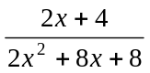for all values of x for which both expressions are defined?
(A) 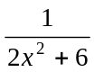
(B) 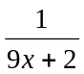
(C) 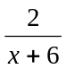
(D) 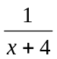
(E) 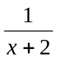
9. A certain business printer can print 40 characters per second, which is 4 times as fast as an average printer. If an average printer can print 5 times as fast as an electric typewriter, how many characters per minute can an electric typewriter print?
(A) 2
(B) 32
(C) 50
(D) 120
(E) 600
10. When ticket sales began, Pat was the nth customer in line for a ticket, and customers purchased their tickets at the rate of x customers per minute. Of the following, which best approximates the time, in minutes, that Pat had to wait in line from the moment ticket sales began?
(A) (n - 1) x
(B) n + x –1
(C) 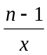
(D) 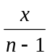
(E) 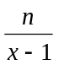

11. If 6 gallons of gasoline are added to a tank that is already filled to of its capacity, the tank is then filled to 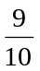 of its capacity. How many gallons does the tank hold?
(A) 20
(B) 24
(C) 36
(D) 40
(E) 60
12. A bus trip of 450 miles would have taken 1 hour less if the average speed S for the trip had been greater by 5 miles per hour. What was the average speed S, in miles per hour, for the trip?
(A) 10
(B) 40
(C) 45
(D) 50
(E) 55
13. 10³ is how many times (0.01)³?
(A) 10⁶
(B) 10⁸
(C) 10⁹
(D) 10¹²
(E) 10¹⁸
14. Which of the following groups of numbers could be the lengths of the sides of a right triangle?
Ⅰ. 1, 4, 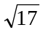
Ⅱ. 4, 7, 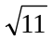
Ⅲ. 4, 9, 6
(A) Ⅰonly
(B) Ⅰand Ⅱ only
(C) Ⅰand Ⅲ only
(D) Ⅱand Ⅲ only
(E) Ⅰ,Ⅱ, and Ⅲ
15. When the stock market opened yesterday, the price of a share of stock X was 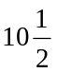. When the market closed, the price was 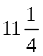. Of the following, which is closest to the percent increase in the price of stock X?
(A) 0.5%
(B) 1.0%
(C) 6.7%
(D) 7.1%
(E) 7.5%
16. If x and y are integers and xy² is a positive odd integer, which of the following must be true?
Ⅰ. xy is positive.
Ⅱ. xy is odd.
Ⅲ. x + y is even.
(A) Ⅰ only
(B) Ⅱ only
(C) Ⅲ only
(D) Ⅰ and Ⅱ
(E) Ⅱ and Ⅲ

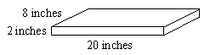
17. The figure above shows the dimensions of a rectangular box that is to be completely wrapped with paper. If a single sheet of paper is to be used without patching, then the dimensions of the paper could be
(A) 17 in by 25 in
(B) 21 in by 24 in
(C) 24 in by 12 in
(D) 24 in by 14 in
(E) 26 in by 14 in

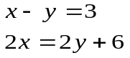
18.

The system of equations above has how many
solutions?
(A) None
(B) Exactly one
(C) Exactly two
(D) Exactly three
(E) Infinitely many

19. If M and N are positive integers that have remainders of 1 and 3, respectively, when divided by 6, which of the following could NOT be a possible value of M+N?
(A) 86
(B) 52
(C) 34
(D) 28
(E) 10
20. The R students in a class agree to contribute equally to buy their teacher a birthday present that costs y dollars. If x of the students later fail to contribute their share, which of the following represents the additional number of dollars that each of the remaining students must contribute in order to pay for the present?
(A) 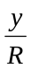
(B) 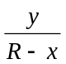
(C) 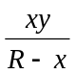
(D) 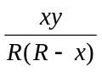
(E) 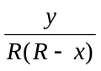
SECTION 3
30 Minutes (20 Questions)
1. 6.09 – 4.693 =
(A) 1.397
(B) 1.403
(C) 1.407
(D) 1.497
(E) 2.603
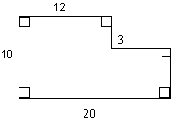
2. What is the area of the region enclosed by the figure above?
(A) 116
(B) 144
(C) 176
(D) 179
(E) 284
3. If p = 0.2 and n = 100, then 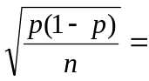
(A) 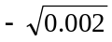
(B) 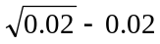
(C) 0
(D) 0.04
(E) 0.4

4. If each of 4 subsidiaries of Corporation R has been granted a line of credit of $700,000 and each of the other 3 subsidiaries of Corporation R has been granted a line of credit of $112,000, what is the average (arithmetic mean) line of credit granted to a subsidiary of Corporation R?
(A) $1,568,000
(B) $448,000
(C) $406,000
(D) $313,600
(E) $116,000
5. If x is a number such that x² – 3x + 2 =0 and x² –x –2= 0, what is the value of x？
(A) –2
(B) –1
(C) 0
(D) 1
(E) 2
6. In traveling from a dormitory to a certain city, a student went of the way by foot, of the way by bus, and the remaining 8 kilometers by car. What is the distance, in kilometers, from the dormitory to the city?
(A) 30
(B) 45
(C) 60
(D) 90
(E) 120
7. A certain elevator has a safe weight limit of 2,000 pounds. What is the greatest possible number of people who can safely ride on the elevator at one time with the average (arithmetic mean) weight of half the riders being 180 pounds and the average weight of the others being 215 pounds?
(A) 7
(B) 8
(C) 9
(D) 10
(E) 11
8. After paying a 10 percent tax on all income over $3,000, a person had a net income of $12,000. What was the income before taxes?
(A) $13,300
(B) $13,000
(C) $12,900
(D) $10,000
(E) $9,000
9. 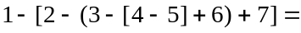
(A) –2
(B) 0
(C) 1
(D) 2
(E) 16
10. The price of a model M camera is $209 and the price of a special lens is $69. When the camera and lens are purchased together, the price is $239. The amount saved by purchasing the camera and lens together is approximately what percent of the total price of the camera and lens when purchased separately?
(A) 14%
(B) 16%
(C) 29%
(D) 33%
(E) 86%
11. If 0.497 mark has the value of one dollar, what is the value to the nearest dollar of 350 marks?
(A) $174 (B) $176 (C) $524
(D) $696 (E) $704
12. A right cylindrical container with radius 2 meters and height 1 meter is filled to capacity with oil. How many empty right cylindrical cans, each with radius meter and height 4 meters, can be filled to capacity with the oil in this container?
(A) 1 (B) 2 (C) 4
(D) 8 (E) 16
13. If a sequence of 8 consecutive odd integers with increasing values has 9 as its 7th term, what is the sum of the terms of the sequence?
(A) 22 (B) 32 (C) 36
(D) 40 (E) 44
14. A rectangular floor is covered by a rug except for a strip p meters wide along each of the four edges. If the floor is m meters by n meters, what is the area of the rug, in square meters?
(A) mn – p (m + n)
(B) mn – 2p(m +n)
(C) mn – p²
(D) (m - p)(n - p)
(E) (m –2p)(n – 2p)
15. Working alone, R can complete a certain kind of job in 9 hours. R and S, working together at their respective rates, can complete one of these jobs in 6 hours. In how many hours can S, working alone, complete one of these jobs?
(A) 18 (B) 12 (C) 9
(D) 6 (E) 3
16. A family made a down payment of $75 and borrowed the balance on a set of encyclopedias that cost $400. The balance with interest was paid in 23 monthly payments of $16 each and a final payment of $9. The amount of interest paid was what percent of the amount borrowed?
(A) 6%
(B) 12%
(C) 14%
(D) 16%
(E) 20%
17. If x≠0 and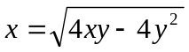, then, in terms of y,
(A) 2y
(B) y
(C) 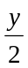
(D) 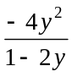
(E) –2y

18. Solution Y is 30 percent liquid X and 70 percent water. If 2 kilograms of water evaporate from 8 kilograms of solution Y and 2 kilograms of solution Y are added to the remaining 6 kilograms of liquid, what percent of this new solution is liquid X?
(A) 30%
(B) 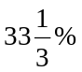
(C) 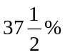
(D) 40%
(E) 50%
19.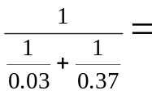
(A) 0.004
(B) 0.02775
(C) 2.775
(D) 3.6036
(E) 36.036
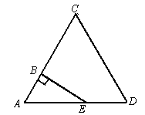
20. If each side of ΔACD above has length 3 and if AB has length 1, what is the area of region BCDE?
(A)
(B) 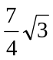
(C) 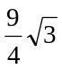
(D) 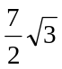
(E) 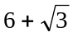
SECTION 4
30 Minutes (20 Questions)
1. Which of the following is equal to 85 percent of 160?
(A) 1.88
(B) 13.6
(C) 136
(D) 188
(E) 13,600
2. The regular hourly wage for an employee of a certain factory is $5.60. If the employee worked 8 hours overtime and earned 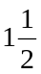 times this regular hourly wage for overtime, how much overtime money was earned?
(A) $67.20
(B) $55.40
(C) $50.00
(D) $44.80
(E) $12.00
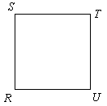
3. Square RSTU shown above is rotated in a plane about its center in a clockwise direction the minimum number of degrees necessary for T to be in the position where S is now shown. The number of degrees through which RSTU is rotated is
(A) 135º
(B) 180º
(C) 225º
(D) 270º
(E) 315º

Questions 4-5 refer to the following graphs.
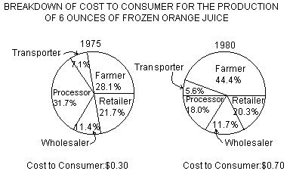

4. Of the following, which is closest to the increase from 1975 to 1980 in the amount received by the processor in producing 6 ounces of frozen orange juice?
(A) $0.03
(B) $0.05
(C) $0.06
(D) $0.08
(E) $0.13
5. In 1980, approximately what fraction of the cost to the consumer for the production of 6 ounces of frozen orange juice went to the farmer?
(A) 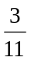 (B) (C)
(D) (E)
6. 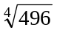 is between
(A) 3 and 4
(B) 4 and 5
(C) 5 and 6
(D) 6 and 7
(E) 7 and 8
7. If x≠0, 2x =5y, and 3z =7x, what is the ratio of z to y?
(A) 2 to 21
(B) 3 to 5
(C) 14 to 15
(D) 6 to 5
(E) 35 to 6
8. A grocer purchased a quantity of bananas at 3 pounds for $0.50 and sold the entire quantity at 4 pounds for $1.00. How many pounds did the grocer purchase if the profit from selling the bananas was $10.00?
(A) 40
(B) 60
(C) 90
(D) 120
(E) 240
9. There are between 100 and 110 cards in a collection of cards. If they are counted out 3 at a time, there are 2 left over, but if they are counted out 4 at a time, there is 1 left over. How many cards are in the collection?
(A) 101
(B) 103
(C) 106
(D) 107
(E) 109

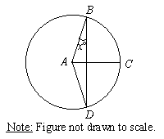
10. If A is the center of the circle shown above and AB=BC=CD, what is the value of x?
(A) 15
(B) 30
(C) 45
(D) 60
(E) 75
11. Out of a total of 1,000 employees at a certain corporation, 52 percent are female and 40 percent of these females work in research. If 60 percent of the total number of employees work in research, how many male employees do NOT work in research?
(A) 520
(B) 480
(C) 392
(D) 208
(E) 88
12. An instructor scored a student’s test of 50 questions by subtracting 2 times the number of incorrect answers from the number of correct answers. If the student answered all of the questions and received a score of 38, how many questions did that student answer correctly?
(A) 19
(B) 38
(C) 41
(D) 44
(E) 46

13. Which of the following integers does NOT have a divisor greater than 1 that is the square of an integer?
(A) 75
(B) 42
(C) 32
(D) 25
(E) 12
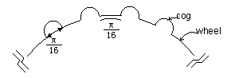
14. There are cogs around the circumference of a wheel and each cog is 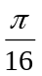 centimeter wide with a space of centimeter between consecutive cogs, as shown above. How many cogs of this size, with the same space between any two consecutive cogs, fit on a wheel with diameter 6 centimeters?
(A) 96
(B) 64
(C) 48
(D) 32
(E) 24
15. If r☉s = rs + r + s, then for what value of s is r ☉s equal to r for all values of r?
(A) –1 (B) 0 (C) 1
(D) 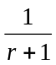 (E) r
16. In each production lot for a certain toy, 25 percent of the toys are red and 75 percent of the toys are blue. Half the toys are size A and half are size B. If 10 out of a lot of 100 toys are red and size A, how many of the toys are blue and size B?
(A) 15 (B) 25 (C) 30
(D) 35 (E) 40
17. If 2x + 5y =8 and 3x = 2y, what is the value of 2x + y?
(A) 4
(B) 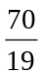
(C) 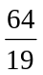
(D) 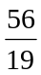
(E) 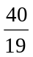

18. A ladder 25 feet long is leaning against a wall that is perpendicular to level ground. The bottom of the ladder is 7 feet from the base of the wall. If the top of the ladder slips down 4 feet, how many feet will the bottom of the ladder slip?
(A) 4 (B) 5 (C) 8
(D) 9 (E) 15
19. What is the least possible product of 4 different integers, each of which has a value between –5 and 10, inclusive?
(A) –5040 (B) –3600
(C) –720 (D) –600
(E) –120
20. If a motorist had driven 1 hour longer on a certain day and at an average rate of 5 miles per hour faster, he would have covered 70 more miles than he actually did. How many more miles would he have covered than he actually did if he had driven 2 hours longer and at an average rate of 10 miles per hour faster on that day?
(A) 100 (B) 120 (C) 140
(D) 150 (E) 160
SECTION 5
30 Minutes (20 Questions)
1. What is the average (arithmetic mean) of the numbers 15, 16, 17, 17, 18, and 19?
(A) 14.2
(B) 16.5
(C) 17
(D) 17.5
(E) 18
2. Kathy bought 4 times as many shares in Company X as Carl, and Carl bought 3 times as many shares in the same company as Tom. Which of the following is the ratio of the number of shares bought by Kathy to the number of shares bought by Tom?
(A)
(B)
(C)
(D)
(E) 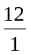
3. Of the following, which if closest to 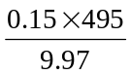?
(A) 7.5
(B) 15
(C) 75
(D) 150
(E) 750
4. A manager has $6,000 budgeted for raises for 4 full-time and 2 part-time employees. Each of the full-time employees receives the same raise, which is twice the raise that each of the part-time employees receives. What is the amount of the raise that each full-time employee receives?
(A) $750
(B) $1,000
(C) $1,200
(D) $1,500
(E) $3,000
5. 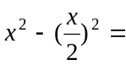
(A) x² - x
(B) 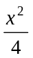
(C) 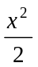
(D) 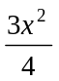
(E) 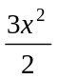
6. A hospital pharmacy charges $0.40 per fluidram of a certain medicine but allows a discount of 15 percent to Medicare patients. How much should the pharmacy charge a Medicare patient for 3 fluidounces of the medicine?(128 fluidrams = 16 fluidounces)
(A) $9.60
(B) $8.16
(C) $3.20
(D) $2.72
(E) $1.02
7. (-1)² - (-1)³=
(A) –2
(B) –1
(C) 0
(D) 1
(E) 2
8. At a certain bowling alley, it costs $0.50 to rent bowling shoes for the day and $1.25 to bowl 1 game. If a person has $12.80 and must rent shoes, what is the greatest number of complete games that person can bowl in one day?
(A) 7
(B) 8
(C) 9
(D) 10
(E) 11
9. 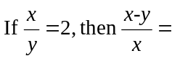
(A) –1
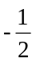(B)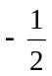
(C)
(D) 1
(E) 2
10. If each photocopy of a manuscript costs 4 cents per page, what is the cost, in cents, to reproduce x copies of an x-page manuscript?
(A) 4x
(B) 16x
(C) x2
(D) 4x2
(E) 16x2
11. Ken left a job paying $75,000 per year to accept a sales job paying $45,000 per year plus 15 percent commission. If each of his sales is for $750, what is the least number of sales he must make per year if he is not to lose money because of the change?
(A) 40
(B) 200
(C) 266
(D) 267
(E) 600
MONTHLY KILOWATT-HOURS
 | 500 | 1,000 | 1,500 | 2,000
Present | $24.00 | $41.00 | $57.00 | $73.00
Proposed | $26.00 | $45.00 | $62.00 | $79.00
12. The table above shows present rates and proposed rates for electricity for residential customers. For which of the monthly kilowatt-hours shown would the proposed rate be the greatest percent increase over the present rate?
(A) 500
(B) 1,000
(C) 1,500
(D) 2,000
(E) Each of the percent increases is the same.
13. If a, b, and c are three consecutive odd integers such that 10<a<b<c<20 and if b and c are prime numbers, what is the value of a + b?
(A) 24 (B) 28 (C) 30
(D) 32 (E) 36
14. Of a group of people surveyed in a political poll, 60 percent said that they would vote for candidate R. Of those who said they would vote for R. 90 percent actually voted for R. and of those who did not say that they would vote for R. 5 percent actually voted for R. What percent of the group voted for R?
(A) 56% (B) 59% (C) 62%
(D) 65% (E) 74%
15. If 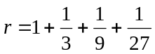 and 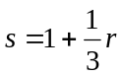, then s exceeds r by
(A) (B) (C)
(D) 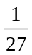 (E) 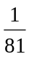

16. 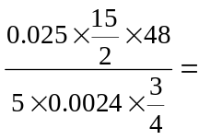
(A) 0.1
(B) 0.2
(C) 100
(D) 200
(E) 1,000
17. A student responded to all of the 22 questions on a test and received a score of 63.5. If the scores were derived by adding 3.5 points for each correct answer and deducting 1 point for each incorrect answer, how many questions did the student answer incorrectly?
(A) 3
(B) 4
(C) 15
(D) 18
(E) 20
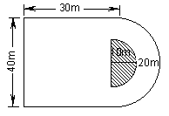
18. The figure above represents a rectangular parking lot that is 30 meters by 40 meters and an attached semicircular driveway that has an outer radius of 20 meters and an inner radius of 10 meters. If the shaded region is not included, what is the area, in square meters, of the lot and driveway?
(A) 1,350π
(B) 1,200 + 400π
(C) 1,200 + 300π
(D) 1,200 + 200π
(E) 1,200 + 150π
19. One-fifth of the light switches produced by a certain factory are defective. Four-fifths of the defective switches are rejected and 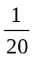 of the nondefective switches are rejected by mistake. If all the switches not rejected are sold, what percent of the switches sold by the factory are defective?
(A) 4%
(B) 5%
(C) 6.25%
(D) 11%
(E) 16%

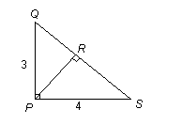
20. In ΔPQS above, if PQ =3 and PS = 4, then 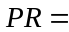
(A)
(B) 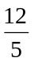
(C) 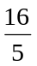
(D) 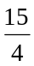
(E) 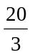
SECTION 6
30 Minutes (20 Questions)
1. If x is an even integer, which of the following is an odd integer?
(A) 3x + 2
(B) 7x
(C) 8x +5
(D) x²
(E) x³
2. On a purchase of $120, a store offered a payment plan consisting of a $20 down payment and 12 monthly payments of $10 each. What percent of the purchase price, to the nearest tenth of a percent, did the customer pay in interest by using this plan?
(A) 16.7%
(B) 30%
(C) 75.8%
(D) 106.7%
(E) 107.5%

3. 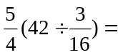
(A) 6.3
(B) 9.8
(C) 179.2
(D) 224
(E) 280
4. When magnified 1,000 times by an electron microscope, the image of a certain circular piece of tissue has a diameter of 0.5 centimeter. The actual diameter of the tissue, in centimeters, is
(A) 0.005
(B) 0.002
(C) 0.001
(D) 0.0005
(E) 0.0002
5. In 1970 there were 8,902 women stockbrokers in the United States. By 1978 the number had increased to 19,947. Approximately what was the percent increase?
(A) 45%
(B) 125%
(C) 145%
(D) 150%
(E) 225%
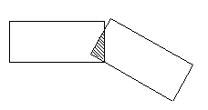
6. In the figure above, two rectangles with the same dimensions overlap to form the shaded region. If each rectangle has perimeter 12 and the shaded region has perimeter 3, what is the total length of the heavy line segments?
(A) 15 (B) 18 (C) 21
(D) 22 (E) 23
7. If one root of the equation 2x² + 3x – k = 0 is 6, what is the value of k?
(A) 90
(B) 42
(C) 18
(D) 10
(E) –10
8. Bottle R contains 250 capsules and costs $6.25. Bottle T contains 130 capsules and costs $2.99. What is the difference between the cost per capsule for bottle R and the cost per capsule for bottle T?
(A) $0.25
(B) $0.12
(C) $0.05
(D) $0.03
(E) $0.002
9. Trucking transportation rates are x dollars per metric ton per kilometer. How much does it cost, in dollars, to transport one dozen cars, which weigh two metric tons each, n kilometers by truck?
(A) 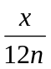
(B) 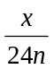
(C) 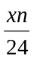
(D) 12xn
(E) 24xn
10. For a positive integer n, the number n! is defined to be n(n - 1)(n - 2)…(1). For example, 4!=4(3)(2)(1). What is the value of 5!-3!?
(A) 120 (B) 114 (C) 20
(D) 15 (E) 2
11. A man who died left an estate valued at $111,000. His will stipulated that his estate was to be distributed so that each of his three children received from the estate and his previous gifts, combined, the same total amount. If he had previously given his oldest child $15,000, his middle child $10,000, and his youngest $2,000, how much did the youngest child receive from the estate?
(A) $50,000
(B) $48,000
(C) $46,000
(D) $44,000
(E) $39,000
12. If y > 0, which of the following is equal to 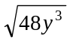
(A) 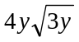
(B) 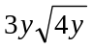
(C) 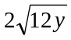
(D) 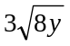
(E) 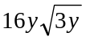

13. The volume of a box with a square base is 54 cubic centimeters. If the height of the box is twice the width of the base, what is the height, in centimeters?
(A) 2
(B) 3
(C) 4
(D) 6
(E) 9
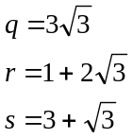

14. If q, r and s are the numbers shown above, which of the following shows their order from greatest to least?
(A) q, r, s
(B) q, s, r
(C) r, q, s
(D) s, q, r
(E) s, r, q
15. The sum of the interior angles of any polygon with n sides is 180(n – 2) degrees. If the sum of the interior angles of polygon P is three times the sum of the interior angles of quadrilateral Q, how many sides does P have?
(A) 6 (B) 8 (C) 10
(D) 12 (E) 14
16. In Company X, 30 percent of the employees live over ten miles from work and 60 percent of the employees who live over ten miles from work are in car pools. If 40 percent of the employees of Company X are in car pools, what percent of the employees of Company X live ten miles or less from work and are in car pools?
(A) 12%
(B) 20%
(C) 22%
(D) 28%
(E) 32%
17. If an organization were to sell n tickets for a theater production, the total revenue from ticket sales would be 20 percent greater than the total costs of the production. If the organization actually sold all but 5 percent of the n tickets, the total revenue from ticket sales was what percent greater than the total costs of the production?
(A) 4% (B) 10% (C) 14%
(D) 15% (E) 18%
18. When the integer n is divided by 6, the remainder is 3, Which of the following is NOT a multiple of 6?
(A) n – 3
(B) n + 3
(C) 2n
(D) 3n
(E) 4n
19. How many liters of pure alcohol must be added to a 100-liter solution that is 20 percent alcohol in order to produce a solution that is 25 percent alcohol?
(A)
(B) 5
(C)
(D) 8
(E) 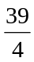
20. If 10 persons meet at a reunion and each person shakes hands exactly once with each of the others, what is the total number of handshakes?
(A) 10·9·8·7·6·5·4·3·2·1
(B) 10·10
(C) 10·9
(D) 45
(E) 36
SECTION 7
30 Minutes (20 Questions)
1. At the rate of $7.50 per hour, how many hours must a person work to earn $232.50?
(A) 25
(B) 27
(C) 29
(D) 30
(E) 31
2. Each month for 6 months the amount of money in a benefit fund is doubled. At the end of the 6 months there is a total of $640 in the fund. How much money was in the fund at the end of 3 months?
(A) $80
(B) $100
(C) $120
(D) $160
(E) $320
3. 6[-2(6-9)+11-23]=
(A) –224
(B) –108
(C) –36
(D) 24
(E) 79
4. 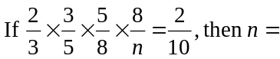
(A) 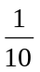
(B)
(C) 5
(D) 10
(E) 100
5. If d= 3.0641 and is the number obtained by rounding d to the nearest hundredth, then 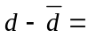
(A) 0.0001
(B) 0.0041
(C) 0.0059
(D) 0.0141
(E) 0.0410
6. Mr. Jones drove from Town A to Town B in x hours. On the return trip over the same route, his average speed was twice as fast. Which of the following expresses the total number of driving hours for the round trip?
(A) 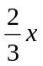
(B) 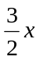
(C) 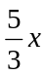
(D) 2x
(E) 3x
7. If 3 is the greatest common divisor of positive integers r and s, what is the greatest common divisor of 2r and 2s?
(A) 2
(B) 3
(C) 4
(D) 6
(E) 12
8. If x +y = 5 and xy=6, then 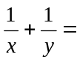
(A)
(B)
(C)
(D)
(E) 5
9. After 5 games, a rugby team had an average of 28 points per game. In order to increase the average by n points, how many points must be scored in a 6th game?
(A) n
(B) 6n
(C) 28n
(D) 28 + n
(E) 28 + 6n
10. On July 1, 1982, Ms. Fox deposited $10,000 in a new account at the annual interest rate of 12 percent compounded monthly. If no additional deposits or withdrawals were made and if interest was credited on the last day of each month, what was the amount of money in the account on September 1, 1982?
(A) $10,200
(B) $10,201
(C) $11,100
(D) $12,100
(E) $12,544
11. How many prime numbers are less than 25 and greater than 10?
(A) Three
(B) Four
(C) Five
(D) Six
(E) Seven
12. Erica has $460 in 5-and 10-dollar bills only. If she has fewer 10-than 5-dollar bills, what is the least possible number of 5-dollar bills she could have?
(A) 32
(B) 30
(C) 29
(D) 28
(E) 27
13. Which of the following is equivalent to the statement that 0.5 is between and ？
(A) 1<n<6
(B) 2<n<3
(C) 2<n<5
(D) 4<n<6
(E) n>10
14. A corporation with 5,000,000 shares of publicly listed stock reported total earnings of $7.20 per share for the first 9 months of operation. During the final quarter the number of publicly listed shares was increased to 10,000,000 shares, and fourth quarter earnings were reported as $1.25 per share. What are the average annual earnings per share based on the number of shares at the end of the year?
(A) $1.83
(B) $2.43
(C) $4.85
(D) $8.45
(E) $9.70
15. In 1980 the government spent $12 billion for direct cash payments to single parents with dependent children. If this was 2,000 percent of the amount spent in 1956, what was the amount spent in 1956? (1 billion = 1,000,000,000)
(A) $6 million
(B) $24 million
(C) $60 million
(D) $240 million
(E) $600 million

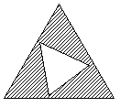
16. The triangles in the figure above are equilateral and the ratio of the length of a side of the larger triangle to the length of a side of the smaller triangle is . If the area of the larger triangular region is K, what is the area of the shaded region in terms of K?
(A) 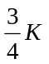
(B) 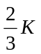
(C) 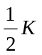
(D) 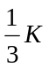
(E) 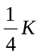
17. Four cups of milk are to be poured into a 2-cup bottle and a 4-cup bottle. If each bottle is to be filled to the same fraction of its capacity, how many cups of milk should be poured into the 4-cup bottle?
(A)
(B)
(C)
(D)
(E) 3

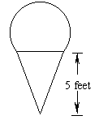
18. The outline of a sign for an ice-cream store is made by placing of the circumference of a circle with radius 2 feet on top of an isosceles triangle with height 5 feet, as shown above. What is the perimeter, in feet, of the sign?
(A) 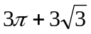
(B) 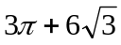
(C) 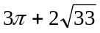
(D) 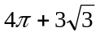
(E) 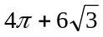
19. The sum of the first 100 positive integers is 5,050. What is the sum of the first 200 positive integers?
(A) 10,100
(B) 10,200
(C) 15,050
(D) 20,050
(E) 20,100
20. A merchant purchased a jacket for $60 and then determined a selling price that equalled the purchase price of the jacket plus a markup that was 25 percent of the selling price. During a sale, the merchant discounted the selling price by 20 percent and sold the jacket. What was the merchant’s gross profit on this sale?
(A) $0
(B) $3
(C) $4
(D) $12
(E) $15
SECTION 8
30 Minutes (20 Questions)
1. A certain club has 237 local branches, one national office, and one social service office. If each local branch has 2 officers, and each of the two other offices has 4 officers, how many officers does the club have altogether?
(A) 482 (B) 476 (C) 474
(D) 239 (E) 235
2. An employee is paid a salary of $300 per month and earns a 6 percent commission on all her sales. What must her annual sales be in order for her to have a gross annual salary of exactly $21,600?
(A) $22,896
(B) $26,712
(C) $300,000
(D) $330,000
(E) $360,000
3. Of the 1,000 students who entered College X as freshmen in September 1979,112 did not graduate in May 1983. If 962 students graduated in May 1983, how many of the graduates did not enter College X as freshmen in September 1979?
(A) 38 (B) 74 (C) 112
(D) 150 (E) 188
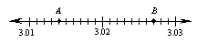
4. On the number line above, what is the length of segment AB?
(A) 13
(B) 1.4
(C) 1.3
(D) 0.13
(E) 0.013

5. Which of the following has a value greater than 1?
(A) 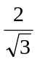
(B) 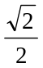
(C) 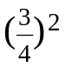
(D) 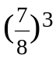
(E) 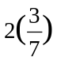

6. If 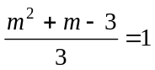， then m could equal
(A) –1
(B) 0
(C) 1
(D) 2
(E) 3
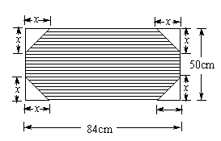
7. The figure above represents a rectangular desk blotter in a holder with dimensions shown. If x = 8 centimeters, what is the area, in square centimeters, of the shaded portion of the blotter?
(A) 4,200
(B) 4,184
(C) 4,124
(D) 4,072
(E) 3,944
8. The number 25 is 2.5 percent of which of the following?
(A) 10
(B) 62.5
(C) 100
(D) 625
(E) 1,000
9. Cottages at a resort are rented for half the summer price in each of the 3 spring months and one-third the summer price in each of the 6 fall and winter months. If each cottage brings in a total of $3,861 when rented for each of the 12 months of the year, what is the monthly rent for each of the 3 summer months?
(A) $297
(B) $594
(C) $702
(D) $858
(E) $1,782

10. In 1980 John’s salary was $15,000 a year and Don’s salary was $20,000 a year. If every year thereafter. John receives a raise of $2,450 and Don receives a raise of $2,000, the first year in which John’s salary will be more than Don’s salary is
(A) 1987
(B) 1988
(C) 1991
(D) 1992
(E) 2000
11. Which of the following is equal to 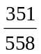?
(A) 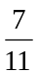
(B) 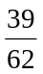
(C) 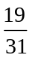
(D) 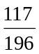
(E) 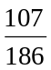
12. On a certain airline, the price of a ticket is directly proportional to the number of miles to be traveled. If the ticket for a 900-mile trip on this airline costs $120, which of the following gives the number of dollars charged for a k-mile trip on this airline?
(A) 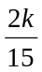
(B) 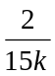
(C) 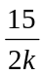
(D) 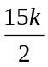
(E) 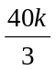
13. If 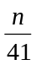 is 1 more than 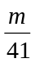, then n =
(A) m – 41
(B) m + 1
(C) m + 41
(D) m + 42
(E) 41m
14. A discount of 20 percent on an order of goods followed by a discount of 10 percent amounts to
(A) less than one 15 percent discount
(B) the same as one 15 percent discount
(C) the same as one 30 percent discount
(D) less than a discount of 10 percent followed by a discount of 20 percent
(E) the same as a discount of 10 percent followed by a discount of 20 percent
15. If k is an even integer and p and r are odd integers, which of the following CANNOT be an integer?
(A) 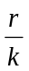
(B) 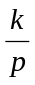
(C) 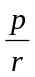
(D) 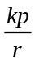
(E) 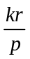
16. Today Al is 3 times as old as Pat, In 13 years, Al will be one year less than twice as old as Pat will be then. How many years old is Al today?
(A) 12
(B) 33
(C) 36
(D) 42
(E) 49
17. When the integer n is divided by 17, the quotient is x and the remainder is 5. When n is divided by 23, the quotient is y and the remainder is 14. Which of the following is true?
(A) 23x + 17y =19
(B) 17x –23y = 9
(C) 17x +23y =19
(D) 14x + 5y = 6
(E) 5x – 14y = -6

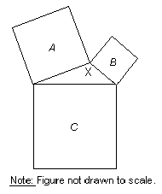
18. In the figure above, three squares and a triangle have areas of A, B, C, and X as shown. If A = 144, B=81, and C=225, then X =
(A) 150
(B) 144
(C) 80
(D) 54
(E) 36
19. Three types of pencils, J,K, and L, cost $0.05, $0.10, and $0.25 each, respectively. If a box of 32 of these pencils costs a total of $3.40 and if there are twice as many K pencils as L pencils in the box, how many J pencils are in the box?
(A) 6
(B) 12
(C) 14
(D) 18
(E) 20
20. Forty percent of the rats included in an experiment were male rats. If some of the rats died during the experiment and 30 percent of the rats that died were male rats, what was the ratio of the death rate among the male rats to the death rate among the female rats?
(A) 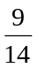 (B) (C) 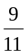
(D) (E)

